

# Programming Web/Cloud/Mobile

# # Lab 1 Assignment

**Team Members:** Pragathi Thammaneni Sridevi Mallipudi

LAB -1 Assignment

# Introduction:

This Lab assignment deals with the the basic web technologies HTML, CSS ,JavaScript with responsive web design(RWD) .In this lab assignment it primarily focuses on the basic topics of Web Programming .

# Objectives:

To code for the 6 questions by implementing the below concepts**.**

* HTML CSS, JavaScript
* AJAX
* Responsive web design

# Approaches /Methods:

Using HTML 5, CSS 3, JavaScript and Web Strom

# Workflow &Datasets/Parameters and Evaluation:

The below each question will follow different approaches to solve. Coding is done to perform the evaluation of each individual snippet to build an e commerce website which is responsive.

# Question 1:

**A screenshot of a cell phone

Description generated with very high confidence**

**Solution:**

Home Page:

Below is the screenshot of the home page of our e-commerce web application. It contains different categories for shopping, users can select the respective category and can navigate to the product details page

**A screenshot of a cell phone

Description generated with very high confidence**

#### Login and Registration Pages:

The home page also contains the option to login into the user account by clicking the Login/Registration button. On clicking the login button users are redirected to login page where users should provide username and password.

**A screenshot of a computer

Description generated with very high confidence**

We implemented the validations for the login page. If the users try to login without providing all the details, a popup error message is displayed to the user.

**A screenshot of a computer

Description generated with very high confidence**

**A picture containing screenshot

Description generated with very high confidence**

In home page if users select the particular category they are redirected to the products details page where users can select the items.

**A screenshot of a cell phone

Description generated with very high confidence**

**A screenshot of a computer screen

Description generated with very high confidence**

In home page users can view the recent orders by clicking on myAccount button and selecting the MyOrders option from the drop down. Below is the screenshot.

**A screenshot of a cell phone

Description generated with very high confidence**

**Recent order history**

**A screenshot of a computer

Description generated with very high confidence**

**Responsive web design:**

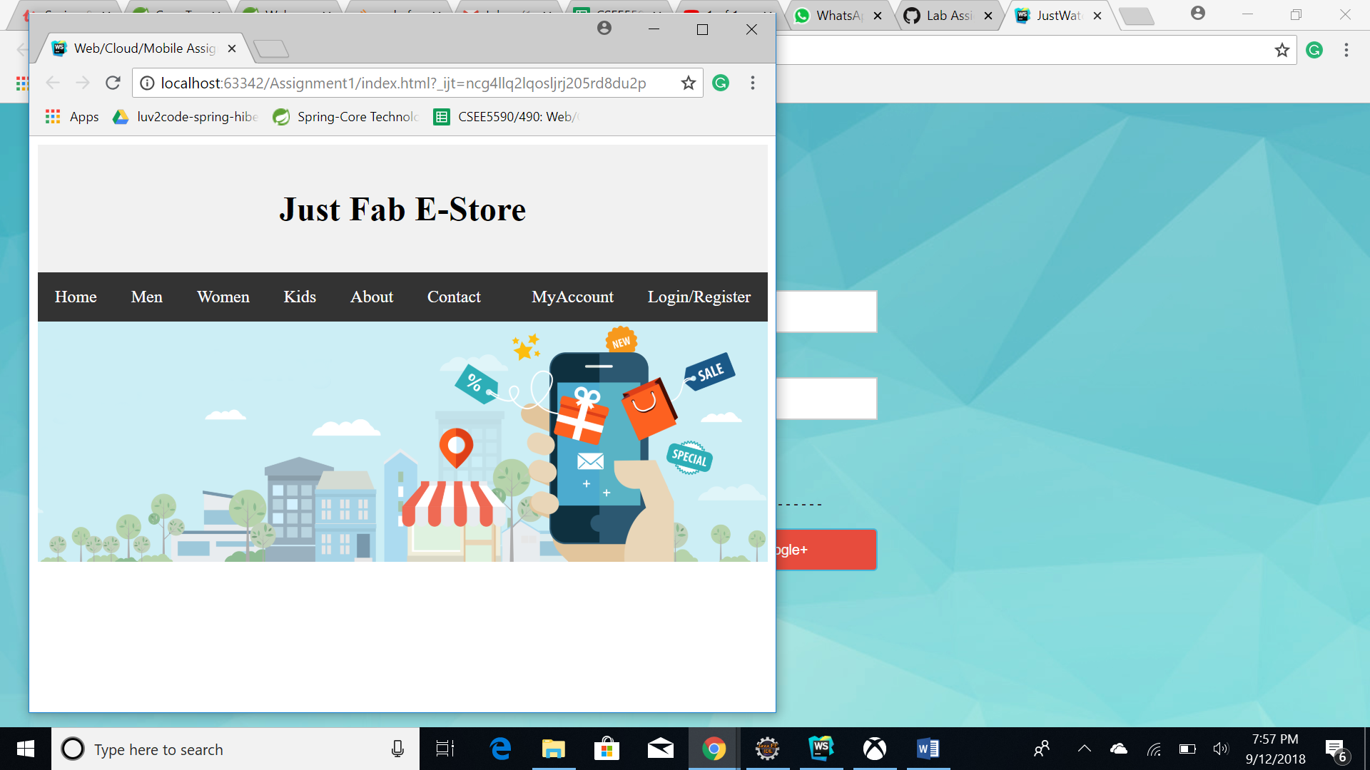

**Conclusion:**

As stated the above workflow with certain set of parameters is followed in solving the execution by implementing the core and basic concepts of the web programming.

# Source code link: <https://github.com/Sridevi333/Programming-web-cloud-mobile/tree/master/Assignments/Assignment%201>

**Video Link:** <https://youtu.be/tGjLFrq_zEQ>

# Wiki Link:

[https://github.com/Sridevi333/Programming-web-cloud-mobile/wiki/Lab-Assignment-1](https://github.com/Sridevi333/Programming-web-cloud-mobile/wiki/Lab-Assignment-1%0c)